WebQuest: Technologies Australian Curriculum
1. Technologies consist of two broad sub-areas _________________ & ___________________
Look under
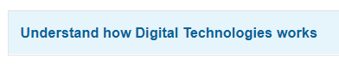
2. Complete the key strands of each sub-area
Area
Strands

3. Insert/replace the ‘wheel diagram for both learning areas’

4. Find this and paste in the PDF files
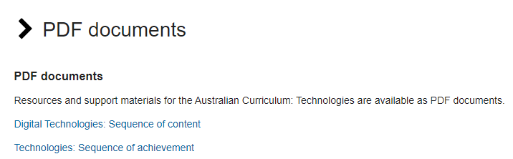

5. Select the year levels F-2, 3 & 4, 5 & 6 and submit
Paste in a screen shot of the expanded KNOWLEDGE and UNDERSTANDING for each area
Design & Technology

Digital Technology

5. Similarly paste in the Process & Production Skills expanded

6. Complete the venn diagram for the two sub-areas
Digital Technology
Design & Technology

