Task 1

Task 1
CU624 Primary the Arts and Technology
Word count:
Part A: 1094 words
Part B: 928 words

Contents
Part A- Safe, Responsible and Ethical use of Technology 2
Introduction 2
Safe, Responsible, and Ethical Use of Technology 2
Cyberbullying Issues 3
Cyberbullying Solutions 3
Inappropriate, Offensive and Illegal Content Issues 4
Inappropriate, Offensive and Illegal Content Solutions 4
Identity Protection and Spam 4
Identity Protection and Spam Solutions 4
Digital Citizenship and Conclusion 5
PART B-Links to Art Curriculum and Scratch Animated Game 6
Links to Media Arts Curriculum 6
References 12

Part A- Safe, Responsible and Ethical use of Technology

Introduction
This task will discuss the issues around the safe and ethical use of ICT’S in primary school, then explain a ‘scratch’ project and its links to the Arts curriculum in Australia. The use of ICT’s inside and outside the school and the workforce is increasingly essential for students to become active and informed citizens for the future (Berry, et al., 2019). On the other hand, the issues that arise with unlimited access to technology are pertinent. The Australian Professional Standards for Teachers specifically states in standard 4.5 that teachers must create and maintain supportive and safe learning environments that use ICT safely, responsibly, and ethically (Australian Insitute for Teaching and School Leadership, 2021). Furthermore, applying social and ethical protocols and practices when using ICT’s is a general capability in the curriculum (Australian Curriculum, Assessment and Reporting Authority, 2021).
Moreover, as Christian teachers, it is essential to support and create a safe, loving environment with clear boundaries and solutions when the use of ICT’s goes wrong. In this paper, the safe and ethical use of technology around the three main issues of cyberbullying, inappropriate content, and identity protection. Solutions for parents and teachers around these issues are also elaborated, emphasising digital citizenship.

Safe, Responsible, and Ethical Use of Technology
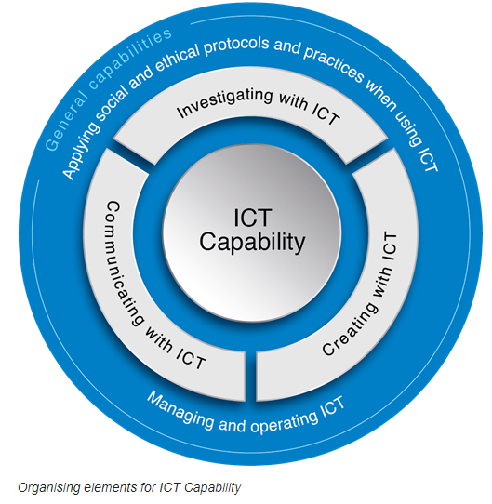
The safe, responsible, and ethical use of ICT’s are separated into three subjects. Safe use of ICT’s indicates that teachers need to support students in the correct ways to avoid inappropriate information and behaviours online, protect themselves whilst interacting online, and knowledge of the risks involved with online interaction. These areas of safety are can also be grouped into three broad categories content viewed, contact participation, and conduct of the student (Byron, 2008). Responsible use of technology involves teaching students to protect their identity online and what to do if they are unsure about the content they have viewed. Finally, the ethical use of technology means teaching children about not only right and wrong content produced, viewed, or interacted with but also the laws of copyright and understanding the concepts of plagiarism and referencing. These three areas identified in the curriculum cover a multitude of issues, but the critical areas encompassed in this report will be cyberbullying, inappropriate content and identity protection
(Australian Curriculum, Assessment and Reporting Authority, 2021)

Cyberbullying Issues
Cyberbullying is a huge issue worldwide and is increasingly becoming evident in upper primary schools in Australia. The definition of bullying is systematic abuse of power with physical, verbal, and social elements (Campbell, et al., 2020). Cyberbullying is unique in the sense that it is mainly social and often verbal (written or video recorded) and takes place anywhere or anytime online using a mobile, laptop or technology device (Raising Children Network (Australia), 2020). Often it is repetitive and can spread exponentially. One in five Australian young people reported being socially excluded, threatened, or abused online, fifty-five per cent asked for help from their parents, and one in five Australian young people admitted behaving negatively to a peer online (Australian Government, 2017). Teachers must ensure that students are safe in person and online. Therefore, several strategies to address cyberbullying need to be established.

Cyberbullying Solutions
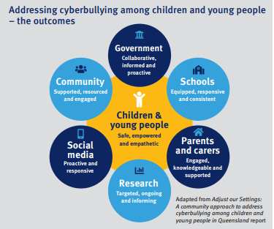
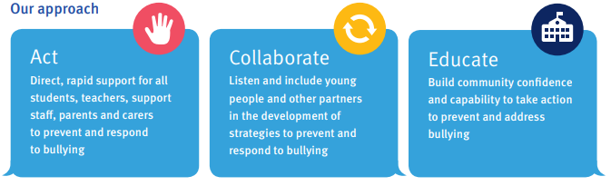
Tackling the issue of cyberbullying is essential for students to feel safe and secure in the school community. The Queensland Government has established an Anti-Cyberbullying Taskforce that has collaborated with stakeholders to provide a threefold plan. Their approach involves acting directly and rapidly to support, prevent, and respond to bullying online. They are followed by collaboration, which consists of listening and including students and stakeholders in developing prevention strategies and finally educating and building the community confidence and capability to act and prevent and address bullying (Queensland Government, 2018). This approach to cyberbullying supports the school community to address the issues. Another practical solution for students is accessed via the e-safety commissioner’s website. The e-safety commissioners’ instructions include resisting the urge to respond, screenshotting evidence, reporting and blocking users, talking to someone, and finally reporting to e-safety (Austarlian Government, 2020). These simple yet effective solutions give students practical tools to use when combating online abuse.
(Austarlian Government, 2020)

Inappropriate, Offensive and Illegal Content Issues
Students are naturally curious when searching online, but it is known that this can sometimes lead to inappropriate content. In most cases, children do not intentionally seek out inappropriate material. Often, they accidentally access it whilst completing online searches (Raising Children Network (Australia), 2020). Offensive and illegal content can involve topics, images and other information that is barred in Australia and could cause emotional and damaging effects to young people online (NSW Police Legacy, 2020). Some inappropriate material may be too mature for young children to handle and can distress children. Furthermore, children often do not report seeing inappropriate content because they feel ashamed or feel like it is their fault. The teacher’s role is to ensure a plan and process when children view, create or access inappropriate material.

Inappropriate, Offensive and Illegal Content Solutions
Creating a strategy to protect children from inappropriate, offensive, and illegal content is vital for student wellbeing. Firstly, establishing a trusting and safe relationship between parents, teachers, and students allows openness and encourages children to speak up when they have seen or taken part in inappropriate content (NSW Police Legacy, 2020). Secondly, setting filters, labels and safe zones reduce the risk of exposure to inappropriate sites. Finally, supervise and research what children are viewing before allowing them to explore new sites (Raising Children Network (Australia), 2020). Websites like Common Sense Media can support teachers and parents to make safe and appropriate choices when it comes to content online (Common Sense Media, 2020). These three solutions support teachers to keep children safe from inappropriate material online.

Identity Protection and Spam
Identity protection and spam is also another issue that needs consideration. It is no secret that children from 5–12-year-olds are the overly exploited ‘tween’ market to online advertisers (Selwyn, Potter, & Cranmer, 2010). Online advertisers use incentives to collect users’ postcodes, date of birth and other personal information. This personal information is used for advertising products or, in some cases, to ‘groom’ children (Poore, 2016). Not only is giving personal information online dangerous it can also lead to identity theft, spam, financial issues, and child exploitation. Teachers must be aware of these websites and ensure children are supported and kept safe.

Identity Protection and Spam Solutions
Students need to be educated and provided solutions to empower their identity protection online. Some solutions include setting strong passwords, not sharing personal information, reading user agreements and privacy policies and, if in doubt, calling the organisation it claims to represent to test legitimacy (Esafety Commisioner, 2020). It is also valuable to teach students about the risks involved with giving out personal information and ensure students understand the consequences.

Digital Citizenship and Conclusion
The education of students, parents and carers can lead to the development of consistent digital citizenship. Being a great digital citizen means being respectful of online behaviour and its effects, being responsible critical thinkers and navigating safe ways to protect security, privacy, and wellbeing online (NSW Department of Education, 2018). Ensuring the relevant and practical education can prevent and help students address cyberbullying, inappropriate content, and identity protection online and into the future.
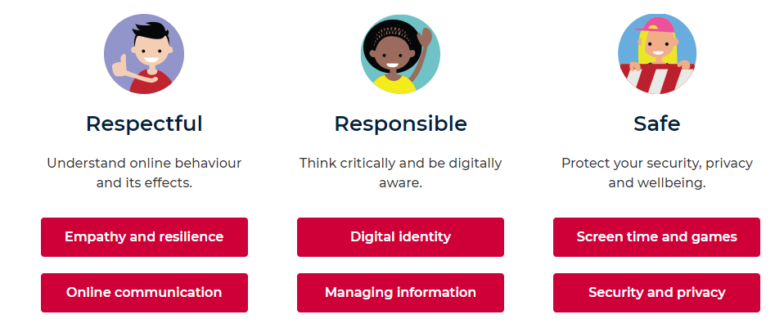
(NSW Department of Education, 2018)

PART B-Links to Art Curriculum and Scratch Animated Game

Links to Media Arts Curriculum
The Media Arts subject area embodies the creation of representations of the world and sharing stories through communication technology. This project encompasses the content descriptor: Plan, Produce and present media artworks for specific audiences and purposes using responsible media practice (ACAMAM064) (ACARA, 2021). In years 5 and 6, students become increasingly skilled with media arts and learn to create animated games and the valuable skills around digital citizenship. Below is an explanation of a project I have completed using a coding program called Scratch. The creation of this program is an example of what a year 5-6 student might produce over a media arts unit. You can access the online animation here: https://scratch.mit.edu/projects/559712874.
Code Component | Explanation
Sprite: Ball | To play music in the game continuously, these blocks were used.  - =start the game.  - = creates a continuous loop of the block or blocks inside it.  - 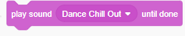=identifies the choice of music.  - The repeat block ensures the music plays in a loop three times.
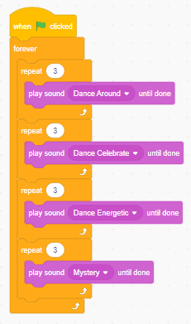
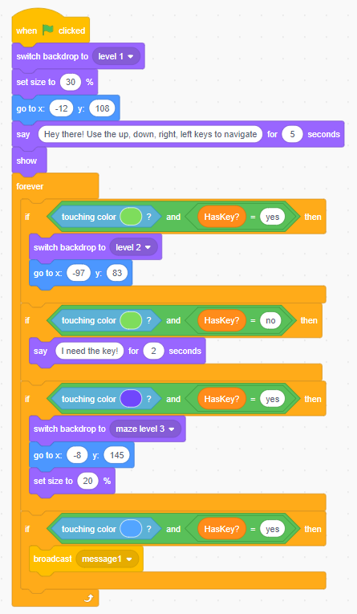 | This code is responsible for the size, position and text spoken from the Ball sprite. It also helps the gamer transition through the levels (backdrops) and ensures they collect the key before proceeding to the next level.  - Ensures the backdrop sets to the first maze, the sprite is visible, the right size and position and the sprite gives a word bubble to the gamer for the instructions.  - Instructs the sprite when it touches the key and touches the ‘finish’ sprite to switch to the next level. The second part reminds the player to collect the key to finish the maze.  - Ensures the player has touched the purple finish sprite and has the key to move on to the third level. It also reduces the size of the sprite and changes its position when starting the final maze.  - When sprite finishes the last level, a message is broadcasted to the champ09 and sprite 2 to ensure they appear at the end of the game
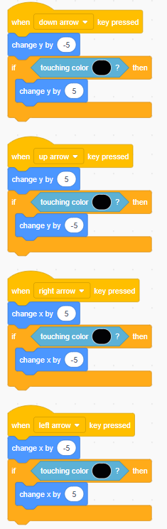  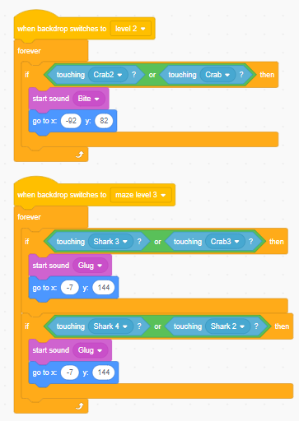 | This part of the code ensures the correct navigation and movement of the ball sprite when the up, down, left and right buttons are pressed on the keyboard.  - This event block controls the ball sprites movements when the player presses the down arrow on the keyboard. If the ball touches a black line the movement is reversed ensuring the block doesn’t move through the lines of the maze.  - The following segments are designed as above only alternating depending on movement required.  - These two chunks of code make the ball sprite restart the maze when touching the crab or shark sprites in maze 2 and 3.
Sprite 1: Level 1 | This code gives instruction for sprite 1.  - Event block that gives instructions when something happens in the game. In this case it gives instruction for the sprite to show during level 1 of the game then hide for the rest of the levels.
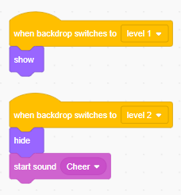
Sprite 3: Level 2 | This code gives instruction for sprite 3.  - These blocks instruct the sprite to only show when the player is on the second maze.
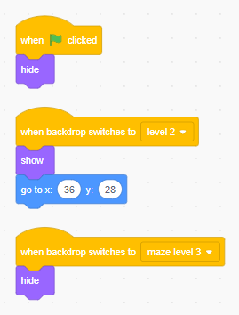

Sprite 4: Level 3 | This code gives instruction for Sprite 4.  - This sprite is the final finish sprite of the game. Therefore, I did not want it to appear in the first two mazes. Hence, I used the events blocks to hide it when pressing start and in the second maze. The final event block ‘when backdrop switches to maze level 3’ then allows the sprite to visible to the gamer in the last maze.
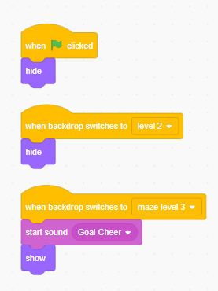

Sprite 2: 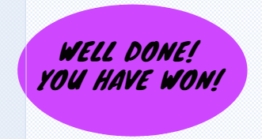 | This code communicates with the other sprite to follow instructions.  - This code hides until it receives a message from the ball sprite (from above broadcast message 1 block) that it has touched the final finish sprite. When the message is received, the sprite is instructed to appear finishing the game.
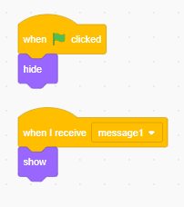
Key sprite | This code is the instructions for visibility before and after the ball sprite touches key.  - Ensures the sprite is visible when the game starts, and the variable is set to no as the sprite has not been collected.  - Instructs the key sprite to hide and make magic spells sound when the ball sprite touches it. This gives the gamer the concept that they have collected the key sprite and can now head to the finish line of the current maze.  - The ‘When backdrop switches to Level 2’ block resets the key sprite from the above instructions to make it visible again for the gamer to collect in the second maze. The variable block is also adjusted to show that the player has not got the key when they start maze 2.  - As above only for the final maze.
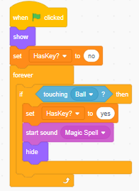
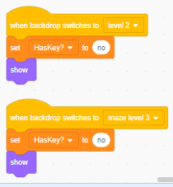

Champ09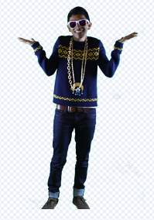 | These blocks control the Champ09 sprites movements throughout the game.  - When the player clicks the green flag, the sprite is instructed to hide.  - The sprite only becomes visible when the ball sprite broadcasts message one. Then sprite goes to the allocated position on the screen and recorded voice over appears.  - Sprite is instructed to repeat the below instructions 10 times which is achieved with the repeat block. The sprite waits 1 second then glides to a random position followed by next costume. I then repeated these blocks as a bug fix because the sprite didn’t move around the screen with just the three blocks on repeat.
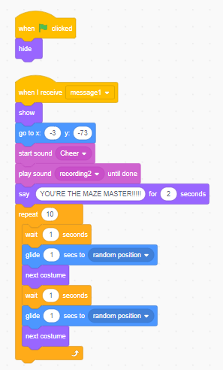

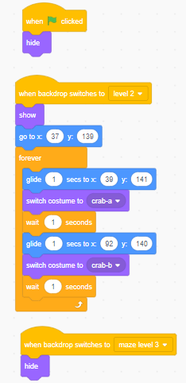 | - This ensures the crabs are only visible in maze two, move correctly around the screen and change costume. Similar code is used to control the shark sprite.
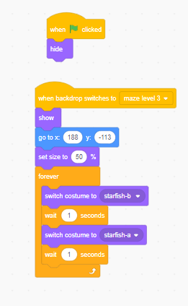 | - This code controls the dancing starfish in the final maze. Ensuring they dance and appear at the correct time.

References
ACARA. (2021, August 19). Media Arts. https://www.australiancurriculum.edu.au/f-10-curriculum/the-arts/media-arts/?year=12739&capability=ignore&capability=Literacy&capability=Numeracy&capability=Information+and+Communication+Technology+%28ICT%29+Capability&capability=Critical+and+Creative+Thi
Austarlian Government. (2020, August 18). Cyberbullying. https://www.esafety.gov.au/young-people/cyberbullying
Australian Curriculum, Assessment and Reporting Authority. (2021, August 17). Information and Communication Technology (ICT) Capability. https://www.australiancurriculum.edu.au/f-10-curriculum/general-capabilities/information-and-communication-technology-ict-capability/
Australian Government. (2017, June 30). eSafety Commissioner. https://www.esafety.gov.au/key-issues/cyberbullying
Australian Insitute for Teaching and School Leadership. (2021, August 17). Australian Professional Standards for Teachers. https://www.aitsl.edu.au/teach/standards
Berry, Y., Tehan, D., Mitchell, S., Uibo, S., Grace, G., Gardner, J., . . . Ellery, S. (2019). Alice Springs (Mparntwe) Education Declaration. Alice Springs: Education Council.
Byron, T. (2008, August 17). Safer Children in a Digital World: The Report of the Byron Review. file:///C:/Users/jessh/Downloads/qs_safe_responsible.pdf
Campbell, M., Whiteford, C., Duncanson, K., Spears, B., Butler, D., & Slee, P. T. (2020). Cyberbullying Bystanders: Gender, Grade, and Actions among Primary and Secondary School students in Australia. IGI Global.
Common Sense Media. (2020, August 19). EdTech Ratings and Reviews. https://www.commonsense.org/education/
Esafety Commisioner. (2020, August 19). Protect you personal information. https://www.esafety.gov.au/key-issues/how-to/protect-personal-information
NSW Department of Education. (2018, August 19). Digital Citizenship. https://www.digitalcitizenship.nsw.edu.au/
NSW Police Legacy. (2020, August 19). Internet Safety: Inappropriate, Offensive and Illegal Content. http://www.childsafetyhub.com.au/internet-safety-inappropriate-offensive-illegal-content/
Poore, M. (2016). Using Social Media in the Classroom. Sage Publications.
Queensland Government. (2018, January 01). Department of Education. https://behaviour.education.qld.gov.au/supportingStudentBehaviour/BullyingCyberbullying/Documents/stand-out-from-the-crowd-action-plan.pdf
Raising Children Network (Australia). (2020, 01 24). Cyberbullying: what it is and how to avoid it. https://raisingchildren.net.au/pre-teens/behaviour/bullying/about-cyberbullying
Raisng Children Network (Australia). (2020, August 19). Internet Safetey: Children 6-8 Years. https://raisingchildren.net.au/school-age/play-media-technology/online-safety/internet-safety-6-8-years
Selwyn, N., Potter, J., & Cranmer, S. (2010). Primary Schools and ICT Learning from Pupil Perspectives. Continuum International Publishing Group.

