Activity Plan
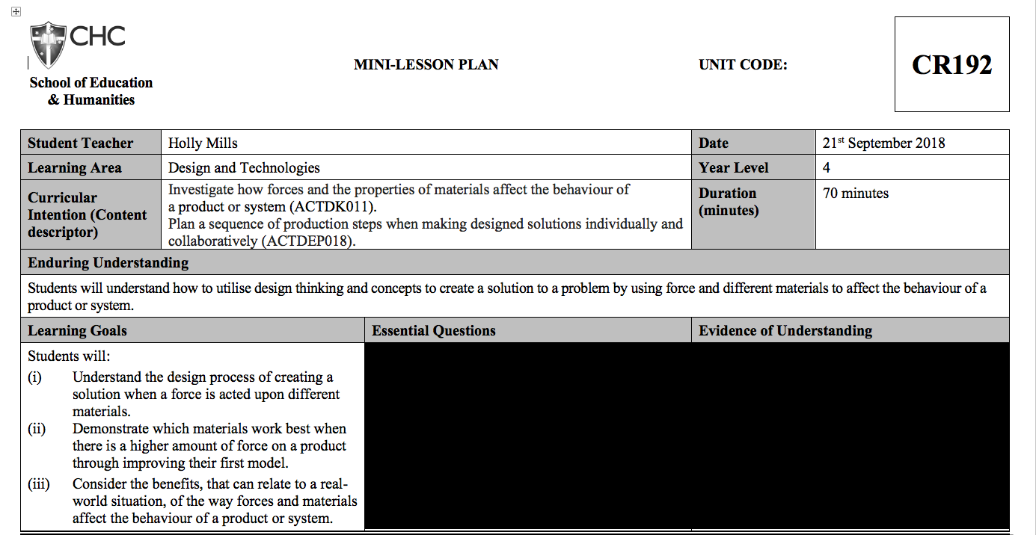
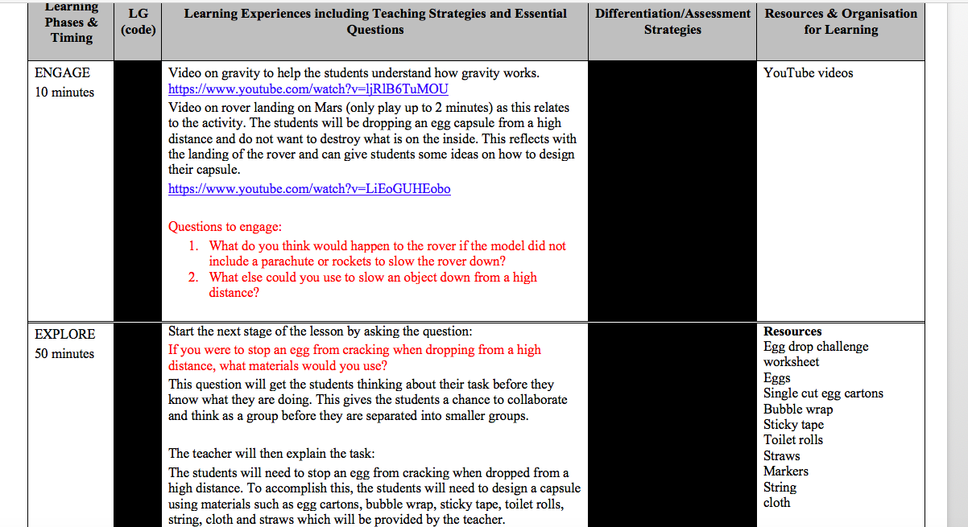
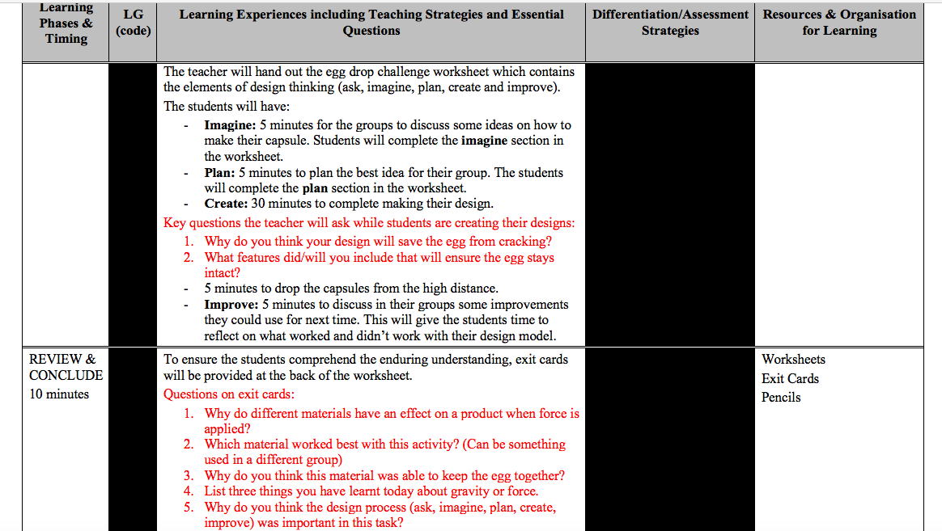
Rationale
The purpose of this task is to explore an aspect of the Australian Curriculum design and technology content area which will help students decipher design thinking/concepts. The content descriptor for grades three to four that this lesson plan was created from aims to, “investigate how forces and the properties of materials affect the behaviour of a product or system (ACTDEK011)” (Australian Curriculum, 2018) and “plan a sequence of production steps when making designed solutions individually and collaboratively (ACTDEP018)” (Australian Curriculum, 2018). The enduring understanding that was created from these content descriptors is that the students will understand how to utilise design thinking and concepts, to create a solution to a problem by using force and different materials to affect the behaviour of a product or system. Design thinking is important for the students to understand because it sets up the foundation for creativity and problem solving (Coleman, 2016). By teaching the five different stages of design thinking, (ask, imagine, plan, create and improve) students are familiarised with this process which leads to the students applying this in their everyday lives and creating a deeper understanding of the process (Coleman, 2016).

The learning goals that were produced for this lesson were: understand the design process of creating a solution when a force is acted upon different materials; demonstrate which materials work best when there is a higher amount of force on a product through improving their first model; consider the benefits, that can relate to a real-world situation, of the way forces and materials affect the behaviour of a product or system.
The first learning goal, understand the design process of creating a solution when a force is acted upon different materials, was included as it is important to for the students to understand how to produce a creative solution through the design process (Spegman, 2017). This lesson will aim to teach the students how forces, particularly gravity, can change how a product performs which will connect with the create and improve stages of design thinking (Watkins, 1997). As the students execute the activity, they will understand which materials gravity had an effect on and which ones did not.

The second learning goal, demonstrate which materials work best when there is a higher amount of force on a product through improving their first model, was incorporated because it is important for the students to make connections with their successes and failures (Schunk, 1991). This is essential because it demonstrates that the students are identifying which materials worked and did not work for them. Through this learning goal they will be able to explain why force has a larger effect on some materials and also how to document their successes and failures (Watkins, 1997 & Schunk, 1991).

Consider the benefits, that can relate to a real-world situation, of the way forces and materials affect the behaviour of a product or system, is the third learning goal that was integrated in this lesson plan. This learning goal is important to the students learning as it is building their awareness and thinking about how they would use this activity in a positive way in their everyday lives (McLaughlin, 2008). The students would incorporate this goal into the imagine stage of design thinking as they would be thinking practically about how they want their capsule to be safe for the egg.

Australian Curriculum Alignment
In years three to four, the design and technologies curriculum is heavily based on the students being able to self-reflect, take ownership and document of their creative ideas through a planning process. Throughout grades three and four, students will have the opportunity to explore different ways to harness their creative ideas, reflect and make improvements to their decision-making skills and recognise real-world problems and solutions to these. With teacher guidance, students will be able to identify the steps taken for a design solution and will understand the importance of planning before creating. By the end of grade four students,

“will have had the opportunity to create designed solutions at least once in the following technologies contexts: Engineering principles and systems; Food and fibre production and Food specialisations; and Materials and technologies specialisations. Students should have opportunities to experience designing and producing products, services and environments” (Australian Curriculum, 2018).
For this lesson plan, the technology context that will be explored is the engineering principles and systems. This engineering context focuses on how forces can be utilised to change, create and manipulate different systems. This is important for the students to be educated on as it assists them in creating sustainable designs and planned out solutions (Coleman, 2016).
The content descriptors that were used for the egg drop activity were, “investigate how forces and the properties of materials affect the behaviour of a product or system (ACTDEK011)” (Australian Curriculum, 2018) and “plan a sequence of production steps when making designed solutions individually and collaboratively (ACTDEP018)” (Australian Curriculum, 2018). The egg drop challenge activity aligns with the content descriptors as the students will be using different types of materials to ensure their egg does not break through the design thinking process. The amount of force placed on the egg capsule will change when being dropped from a high distance, therefore the students need to decipher which materials will slow the capsule down or keep the egg the safest (Dow, Heddleston, & Klemmer, 2009). To be successful at this, the students will need to understand the effects of different force on objects which will help the students pick the right materials for their egg capsule (Dow, Heddleston, & Klemmer, 2009). This activity pushes students to identify “inputs (what goes in to the system), processes (what happens within the system), and outputs (what comes out of the system)” (Australian Curriculum, 2018). This is where the design elements of creative thinking are engaged with the students. Through the five stages, ask, imagine, plan, create and improve, students will understand how and why different materials will affect the outcome of their groups design (Dow, Heddleston, & Klemmer, 2009).

References
Coleman, M. C. (2016). Design thinking and the school library. Knowledge Quest, 62-68.
Design and Technologies, years 3 and 4. (2018). Retrieved from Australian Curriculum: https://www.australiancurriculum.edu.au/f-10-curriculum/technologies/design-and-technologies/?year=12974&strand=Design+and+Technologies+Knowledge+and+Understanding&strand=Design+and+Technologies+Processes+and+Production+Skills&capability=ignore&capability
Dow, S., Heddleston, K., & Klemmer, S. (2009). The Efficacy of Prototyping Under Time Constraints. Creatvity and Cognition, 165-174.
McLaughlin, T. (2008). Nature and inertia. Philosophy Education Society, Inc, 253-284.
Schunk, D. (1991). Self-Efficacy and Academic Motivation. Educational Psychologist, 207-231.
Spegman, A. (2017). Problem-solving and design thinking drive tech school. Beyond The News, 22.
Watkins, E. (1997). The Laws of Motion from Newton to Kant. mit press journals, 311.

Resources
Name:

Egg Drop Challenge
Aim: Design a capsule to protect an egg from cracking or breaking from a high distance drop.
Materials you can use: Single cut egg carton (one per group), sticky tape, bubble wrap, string, straws, cloth and toilet rolls.
Imagine: What are some ideas to solve this problem? Brainstorm ideas within your group. Write them down.

Plan: As a group, choose or combine designs that you think will work best for your groups egg. Draw your design in the box below.

Create: Follow your design using the materials provided to create your capsule. Make sure you write your groups name on the capsule, so you know which one yours is.

Improve: After the eggs have been dropped discuss and write down what worked and what did not work for your groups design.

If you were to complete this task again, what you do different or keep the same?

Exit Card
Once you have completed your exit card, please hand this booklet to your teacher.

Answer these questions:
- Why do different materials have an effect on a product when force is applied?

- Which material worked best with this activity? (Can be something used in a different group)

- Why do you think this material was able to keep the egg together?

- List three things you have learnt today about gravity or force.
1. 2. 3.
5. Why do you think the design process (ask, imagine, plan, create, improve) was important in this task?

