CR192 Study Guide

Week 1 | Activity/Task | Documentation/resources | Additional notes
Learning Goals | Understand the CR192 unit structure  Examine assessment requirements  Explore the Technology Curriculum (Design and Digital)  Develop a justification for this learning area
 | Please complete the following activities
1 | Review Course Overview  - Explore the CR192 website  - Read Overview page  - Scan suggested weekly schedule  - Create your own study schedule with assessment dates  Week Study focus Assessment  3/8/19 Australian Curriculum  10/8/19 Begin task 1  Task 1 Due Date | - Download Unit Outline from Overview page  - Download Assessment Guide from CR192 Overview page | Contact me for Group task allocation
2 | Explore the Technologies Australian Curriculum (AC)  - Watch the Technologies videos  https://www.australiancurriculum.edu.au/f-10-curriculum/technologies/introduction/  - Click, explore, read and take general notes of the website  - Examine the key elements and flow of scope and sequence  - Examine the Digital Technologies Hub  It is great site to further unpack the DT elements and provide practical example of DT in the classroom |  | Link to AC on website
3 | Technologies Discovery Worksheet  - Complete the worksheet | Technologies WebQuest Discovery worksheet  Downloadable from the CR192 website and Moodle
4 | Create a Design and Technologies “mind map”  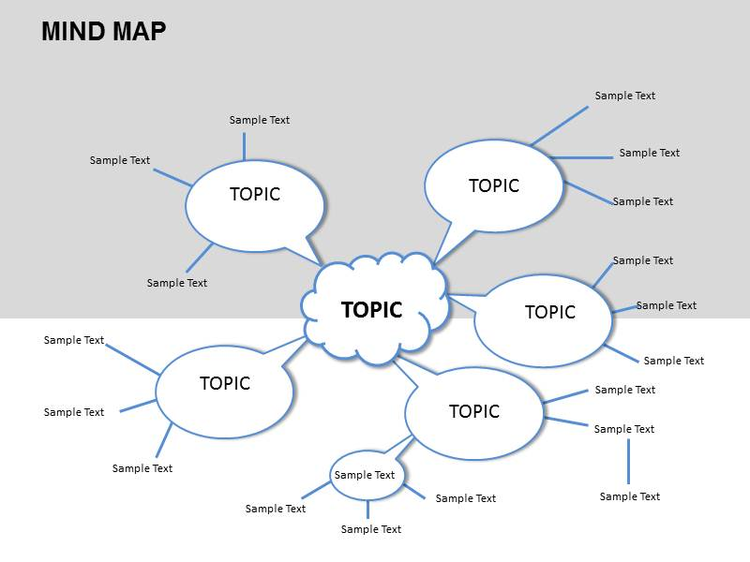 | Try one of the following online mind map programs  Lucidchart  Mindmeister  Bubbl.us  coggle
5 | Write a justification for Technologies within AC (200- 300 words)  “Design and Technologies is important for students because…..” | Post on moodle forum
Submission | - DT justification post (200 words)

Week 2 | Activity/Task | Documentation/resources | Additional notes
Learning Goals | Examine in detail Digital Technology  Gain a knowledge and application of Algorithmic thinking  Evaluate examples of Safe and Responsible Use  Develop an Understanding of Digital Citizenship  Initiate Assessment Task 1
 | Please complete the following activities
1 | Algorithmic Thinking A  - Write a step by step instructions to arise from a chair and move to a different chair (about 5m away) and sit down  - Have another person complete your instructions  - How precise were you?  - What challenges/omissions?  - Think of a similar activity you could undertake in a Year 3-4 classroom
2 | Algorithmic thinking B  - Design a flow chart for dealing with either  - Managing Behaviour Incidents. Include teacher, Year level coordinator, Head of School and Principal with outcomes of warning, lunch detention, suspension and expulsion or  - Assignment extension  Include medical/non-medical, evidence/non-evidence requirements, lateness range of penalties | Use MS office (Word) to create flowchart  Visual Paradigm  Draw.io  creately
3 | Digital Technology: Curriculum elements on CR192 website  - Review and write notes  - Watch videos on algorithmic and computational thinking  - Complete Frayer Model for computational thinking  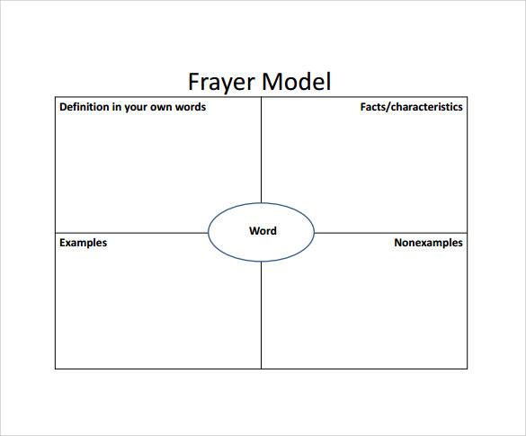 | Frayer Model  (download from CR192 website)
4 | Safe and Responsible Use  - Watch first two videos: The commonsense census and How much screen time is too much?  - Complete the attached questions  Watch the videos on the right and discuss  1. When should children have their own phone?  2. Do you agree with Tristan and Lauren when it comes to what you are doing online? What don’t you agree with?  3. How does social media, gaming, a tablet and phone make a primary aged child's life better? Does it make life worse – in any way?  4. What are some of the problems you’re seeing because of technology in the lives of kids – and what can you personally do about it? What have you previously done about it when you’ve seen it?  5. How much screen time is OK in your opinion ?  6. The screen time video indicate a couple of issues emerging with too much screen time. They were?  7. Suggest a way of preparing students for the increasing array of technology  ​8. What biblical principles could you use in discussion of this topic?
5 | Digital citizenship  - Define the concept  - Watch two associated videos  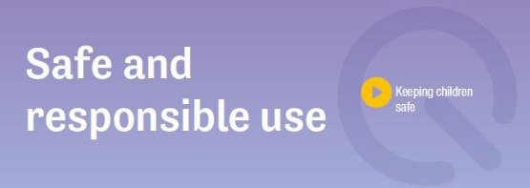  - Read the following  - What Christian principles might guide the discussion on Safe & Responsible use ?  - Review Christian Perspectives (CR92 Website)  - Create a PMI Chart for technology use in schools  (Plus, Minus and Interesting) | Download files from website
6 | Assessment Task 1 (1500 words)  Start reading and writing draft of Safe and Responsible Use section |  | Use some of the websites and docs as part of your task 1 sources
7 | Submit your PMI chart via Moodle

Week 3 | Activity/Task | Documentation/resources | Additional notes
Learning Goals | Develop a knowledge of Digital applications for p-6 contexts  Explore project-based learning pedagogy  Examine common school-based digital applications  Consolidate your choice of digital application for Assessment Task 1
 | Please complete the following activities
1 | Watch Technologies video  CR192 web sites: http://cr192chc.weebly.com/digital-technology-teaching.html
2 | Lesson/activity ideas  - Click and view AC work samples: F-2, 3,4 and 5,6  - Click and scan Digital Technologies Lesson ideas
3 | Project based learning:  What is PBL?  Define constructivism  What is the role of the teacher in PBL (1:00-1:15 and 2:00-2:15 timing)  List the key aspects you may see in a PBL classroom (1:30 -2:30)  Write out 5 examples where you could use a Digital technology PBL topic for a 3/4 primary classroom  Which DT knowledge and process areas does each example develop | https://www.youtube.com/watch?time_continue=153&v=tE6WHn0-cSQ
4 | Video http://cr192chc.weebly.com/digital-technology-teaching.html  - Watch James May Binary video  Write 12 x11 = 132 in binary  Summarise the binary system | Create a Kahoot account
5 | Kahoot Create a Kahoot as an example of use IT in the classroom  Minimum of 8 questions  Topic: knowledge, concepts, examples from weeks 1,2,3
5 | Digital Applications: CR192 Digital Applications Website  - Explore: Blockly, Scratch, Rapid Router and Sphero online animations software
7 | Assessment Task 1  Review the task elements (Overview CR192 web site page)  - Decide on animation software
6 | Send through your kahoot link (Activity 5)

Week  4 & 5 | Activity/Task | Documentation/resources | Additional notes
Learning Goals | Progress the development of digital application  Finalise and submit Task 1
 | Please complete the following activities
1 | Digital Animation  Continue to build and refine your digital animation
2 | Essay writing tutorial  CR192 Academic writing page  http://cr192chc.weebly.com/academic-writing.html | https://www.youtube.com/watch?v=1NErxqpRhk4
WK4 | Submit wk4 progress/draft of Task 1 via turnitin  - Screen shots of animation  - Draft Safe and Responsible use | Exemplars
WK5 | Submit Assessment Task 1 (Wk 5) via turnitin  - Digital animation  - Safe and Responsible use

Week 6 | Activity/Task | Documentation/resources | Additional notes
1 | Sphero Challenge  This challenge is an activity-based session to culminate the Digital Technology aspects of the course.  There are no readings or theory for this week

Week 7 | Activity/Task | Documentation/resources | Additional notes
Learning Goals | Examine in detail the Design Technologies Curriculum  Develop an understanding of Design Thinking  Participate in a design exercise  Examine Assessment Task 2
 | Please complete the following activities
1 | Design Technologies  Curriculum elements  - Summaries web page  - Explore AC site and list key topics covered  in F-2; 3&4; 5&6  - View AC Work samples  - Review scope and sequence for Design technology  http://cr192chc.weebly.com/aust-curric.html  Watch Design thinking video | http://cr192chc.weebly.com/curricular-elements.html  https://www.australiancurriculum.edu.au/f-10-curriculum/technologies/design-and-technologies/
2 | Construction of Spaghetti/paper tower  - Construct a tower using only spaghetti (50 pieces) or newspaper (25 sheets) and masking tape  - At least 35cm tall  - Must hold weighted book (600g)  - Document the process using the Engineering design template  Phases:  - Ask: State the design brief  - Imagine: Through Brainstorming  - Plan: Draw a design  - Create: make the prototype and test  - Improve: suggesting refinements  Test your design | Spaghetti and newspaper  Engineering design template  http://cr192chc.weebly.com/design-technology-projects.html | Complete design template and photo document design phases  Submit via turnitin
3 | Assessment Task 2  Unpacking elements  - Curriculum link to F-2  - Mini-lesson template (attached)  - Similar to spaghetti/paper tower activity | Assessment Guide  Activity-lesson template  http://cr192chc.weebly.com/unit-overview.html
4 | Submit Tower construction documentation via turnitin

Week 8 | Activity/Task | Documentation/resources |  |  | Additional notes
Learning Goals | Gain an understanding of the design process  Select a design activity  Develop a draft lesson/activity plan for the activity  Initiate Assessment Task 2
 | Please complete the following activities
1 | Project-based learning  Watch the following videos:  - Project based learning  - Thinkering studio  Complete Frayer Model (wk 2) on Project-based Learning  Write out 5 examples where you could use a Design Technology PBL topic for a F-2 primary classroom  Which DT knowledge and process areas does each example develop | http://cr192chc.weebly.com/design-technology-projects.html
 | Assessment Task 2 continued  Unpacking elements  - Curriculum link to F-2  - Mini-lesson template & example  Similar to spaghetti/paper tower activity  Explore resources and lessons on CR192 webpage for ideas | Exemplars
2 | Draft lesson/activity  Pre-draft:  - Select AC topic/coverage  - Select activity suitable for F-2  Draft lesson/activity  Lesson Goals: What is the purpose or aim of the activity?  ENGAGE: What is the hook or interesting opening Is there a video or model?  What lead-in or focus questions would you use as prompts?  How do you relate it to the student’s world/experience?  EXPLORE:  - Set up of activity and instructions  - Resources/worksheets required  - Teacher check points  - Lesson sequence/sections  - Design elements  - What are you asking students to produce or do  REVIEW/CONCLUDE: How will you draw out the learning?  Is there a learning worksheet, reflective process or photo or written documentation?
3 | Email to lecturer your draft topic, activity and AC coverage for feedback
Week 9 | Activity/Task |  | Documentation/resources | Additional notes
1 | Assessment Task 2 workshop  Create a learning triangle (3 students)  - (Online students email/skype each other)  - Exchange your activity/lesson drafts with peers for feedback  Complete a peer review  Strengths  Weaknesses  Consider adding  Perhaps change
2 | Submit Assessment task 2 via turnitin

Week 10-13 | Activity/Task | Documentation/resources | Additional notes
1 | Assessment Task 3 tutorials  Meet online or face to face to allocate group tasks  A possible allocation of tasks  Group member Task Components  1 Environmental Issue Issue description (Science) Christian perspective Proposed solution/action  2 Technological solution Technology Solution Design process for model construction Risk management  3 Technology model Physical model Design features/components  4 Digital presentation Rolling ppt or Webpage or Interactive or Video or Combination  All Set up booth Themes & visual elements | Assessment Guide for elaborations | There will not be any formal lectures over these weeks.
2 | Task Organisation  - Elect group chair/organiser  - Create organisation timelines  Group member Task Components Complete Draft date Final date  1 Environmental Issue Issue description (Science) Christian perspective Proposed solution/action  2 Technological solution Technology Solution Design process for model construction Risk management  3 Technology model Physical model Design features/components  4 Digital presentation Rolling ppt or Webpage or Interactive or Video or Combination  All Set up booth Themes & visual elements
3 | Christian Perspectives  http://cr192chc.weebly.com/sustainability.html  - God’s Big story  - Creation theology
4 | Digital presentation (online students)  Online students will create a virtual EXPO utilising a website platform  The website should have separate pages for each of the task components.  The website should contain:  - Written information (Science issue, Technology solution)  - Graphics  - Photographs of model and design process  - Videos of verbal commentator/presentation  Possible website platforms  - Weebly: https://www.weebly.com/au  - My free website: https://www.websitebuilder.com/  - Wix: https://www.wix.com/ | Weebly howto video  https://www.youtube.com/watch?v=v81nRa_W9Fk  wix howto video  https://www.youtube.com/watch?v=K-zI7sC0glo  my free website howto video  https://www.youtube.com/watch?v=MolMObt2mYo
5 | Progress percentage Table  Group member Task Components Wk 11 % drafted Wk 12 % drafted  1 Environmental Issue Issue description (Science) Christian perspective Proposed solution/action  2 Technological solution Technology Solution Design process for model construction Risk management  3 Technology model Physical model Design features/components  4 Digital presentation Rolling ppt or Webpage or Interactive or Video or Combination  All Set up booth Themes & visual elements |  | Email through to lecturer weekly updates
6 | Wk 10:  Email topic and group task allocations and timelines to lecturer for feedback  Wk 11,12: Group organiser: Progress % Table emailed to lecturer

