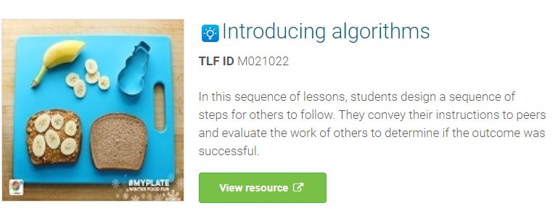Learning hook
Writing a sequence of instructions (algorithms) – whole class activity
- Ask students to consider everyday tasks with a sequence of steps (for example, preparing to play a game using PlayStation, making a sandwich, fixing a puncture on a bicycle tyre, making a cake).
- Ask students to suggest a sequence of steps for cleaning teeth. Remind them to sequence the steps in a logical order.
- Share the Tellagami example with the class. Explain that this is a fast, easy and fun way to share information.
- Rearrange the sequence of steps for cleaning teeth. Support students to understand why order is important when undertaking some tasks. Ask students if they can identify tasks where the order of instructions is very important.
Provide the class with the steps involved in making a vegemite sandwich (out of correct order). Ask students to arrange the instructions in the correct order.
  - Spread vegemite across the surface of the bread
  - Cut the sandwich in half
  - Take two slices of bread from the packet
  - Spread butter across the surface of the bread
  - Place the two slices of bread together

- Give the class a list of everyday tasks. Ask students to select one task and independently write the steps necessary to complete the task.
Examples include:
  - Make a vegemite sandwich
  - Locate and download an app
  - Create and name a new folder on the desktop
  - Make a paper plane
  - Wash the dog
  - Fix a bicycle tyre puncture
  - Make a cup of Milo

Learning input
Dare to square game
- Model the ‘Dare to square’ game.
- Ask students to work in pairs. Provide students with a 4 x 4 grid with two black squares (Grid 1). Explain that the goal is to provide instructions to direct a partner to colour the specific squares within a grid.
For example:
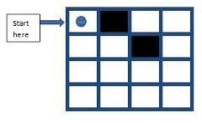
Example grid 1
Suggestion:
  - Move one square to the right.
  - Colour the square
  - Move one square to the right.
  - Move one square down.
  - Colour the square.
Or:
  - Move one square to the right.
  - Colour the square.
  - Move diagonally to the right.
  - Colour the square.

- Provide each student with Example grid 2. Ask them to create a set of instructions to colour the correct squares.
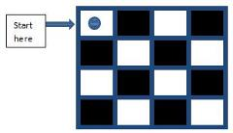
Example grid 2
- After students complete the activity, invite them to share their instructions.
- Display the instructions for all to view. For example:
  - Move one square to the right.
  - Colour the square.
  - Move one square to the right.
  - Move one square to the right.
  - Colour the square.
  - Move one square down.
  - Move one square to the left.
  - Colour the square.
  - Move one square to the left.
  - Move one square to the left.
  - Colour in the square.
  - Move one square down.
  - Move one square to the right.
  - Colour the square.
  - Move one square to the right.
  - Move one square to the right.
  - Colour the square.
  - Move one square down.
  - Move one square to the left.
  - Colour the square.
  - Move one square to the left.
  - Move one square to the left.
  - Colour the square.

- Explain that these instructions would take a long time to write and even longer for a larger grid with more coloured squares.
Ask students to consider an easier and more effective way to provide the instructions. For example, could they use symbols?
Support the students to consider the use of arrows.
- Provide the following suggestion:
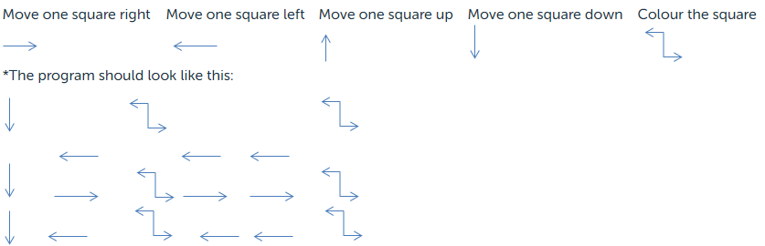
Ask students to imagine they are providing the instructions to a computer. Tell them their task is to use the arrow symbols to provide the instructions instead of the words used previously.
Provide time for each student to use the arrow symbols to create a program instructing the computer to colour the correct squares on the grid.
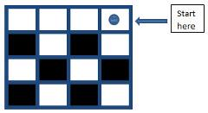

Learning demo
Think, pair share
- Ask students to arrange themselves into pairs.
- Provide each pair with Worksheet 1: Dare to square.
- Explain that each pair will need to view the images on the worksheet. Using the arrow symbols, convert a sequence (algorithm) into a program for others to follow to ensure the correct squares on the grids are coloured.
- Invite students to swap programs with other groups.
- Provide each pair with blank grids and instruct the students to follow the programs to colour the squares on each grid.
- Ask students to create their own versions of the grids and invite other students to provide instructions to complete the tasks.
- Introduce the command repeat. Have the students consider how they can reduce the number of steps by including ‘repeat’ in the algorithm. For example, ‘move one square to the right, colour the square, repeat’.

